**Caribbean Carrot Punch**

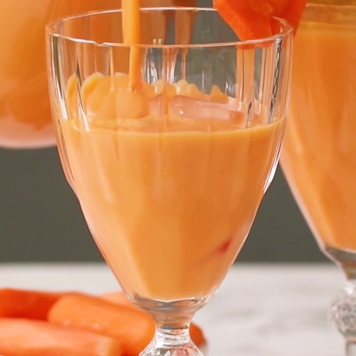

Refreshing on any day, packed with vitamin A and C, and oh so delicious! This drink is a great way to transform the way you eat carrots.

Struggling to get your little ones to eat carrots? Try this drink - it'll be sure to win them over!

**Ingredients**

8 medium sized carrots (to be convert into 4 cups of freshly squeezed carrot juice)

2 cups whole milk or 1 tin vanilla Supligen/Nourishment

1 can sweetened condensed milk

1 tbsp cinnamon

1 tbsp nutmeg

1 tsp vanilla extract

3 tbsp brown sugar (optional - sweeten to your preference)

**METHOD**

**Extracting fresh carrot juice:** Wash and peel carrots. Blend 2 carrots with 1 cup of water, then strain juice into a large jug using a fine seive. Repeat for the remaining carrots, blending 2 carrots with 1 cup of water. You should end up with about 4 cups of fresh carrot juice.

Add the milk (or Supligen), condensed milk, cinnamon, nutmeg, and vanilla extract to the carrot juice in the jug, and mix well.

Further sweeten to taste with brown sugar, if you prefer.

Refrigerate for a couple hours, and then serve over ice. Enjoy!